**Assignment 1: Automated Instance Management Using AWS Lambda and Boto3**

**1. EC2 Setup:**

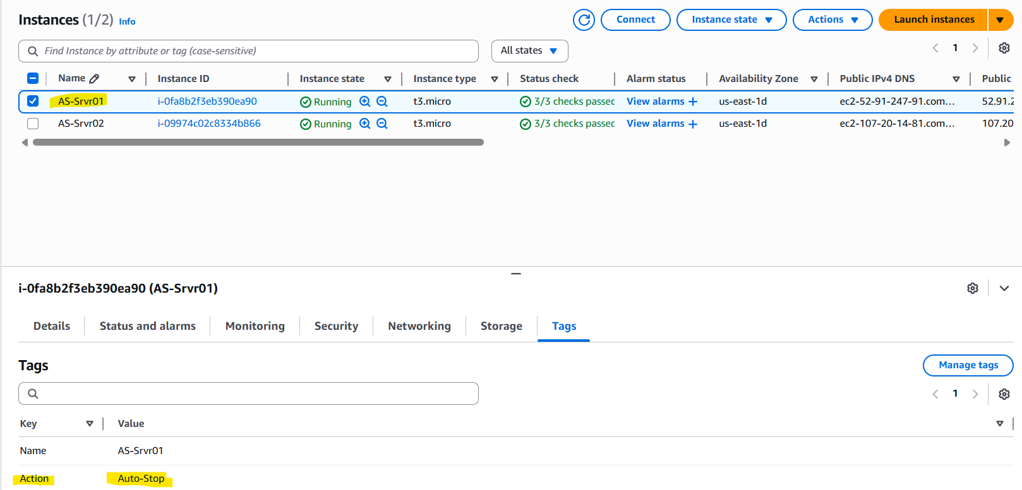

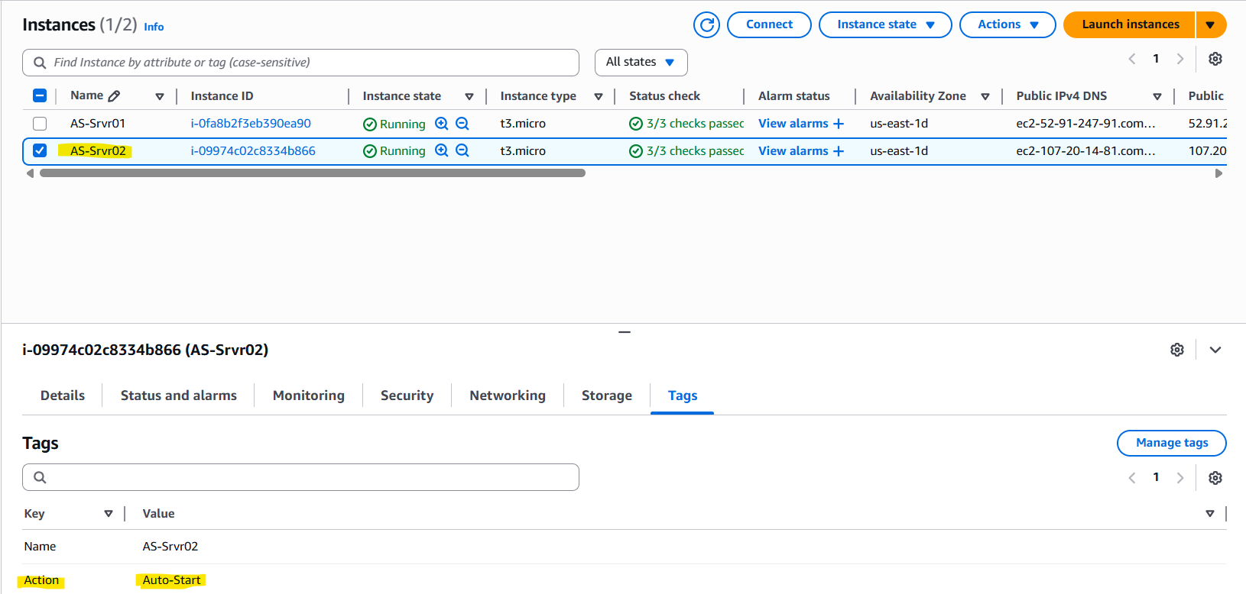

**2. Lambda IAM Role:**

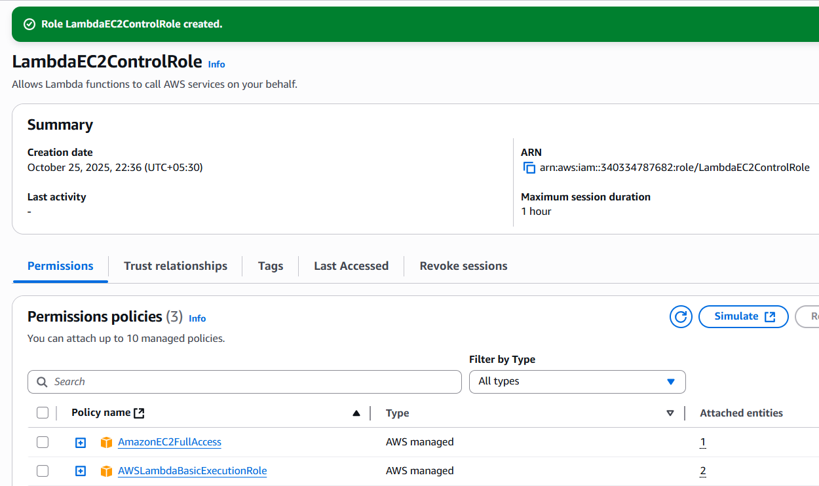

**3. Lambda Function:**

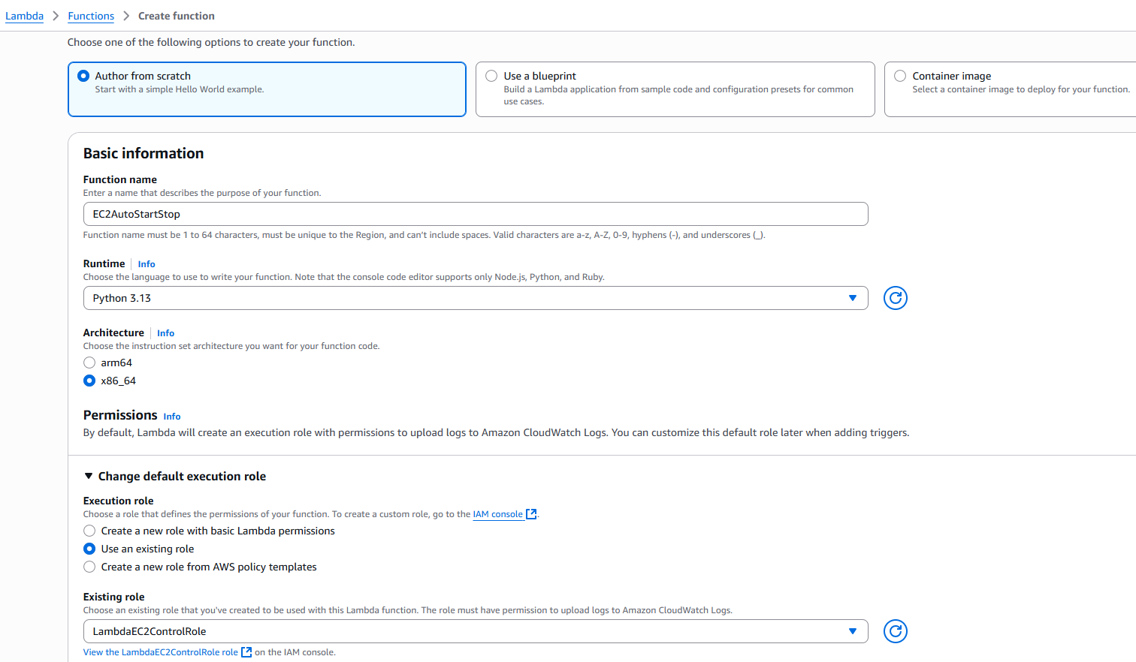

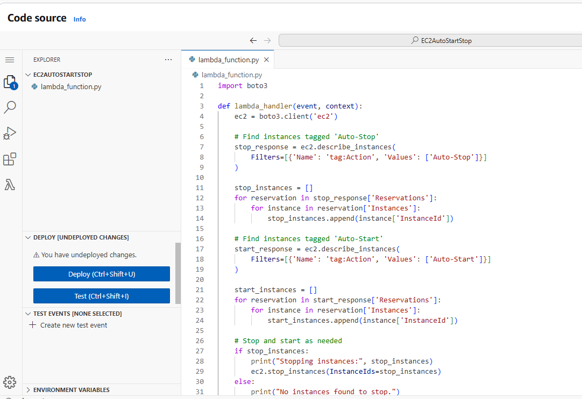

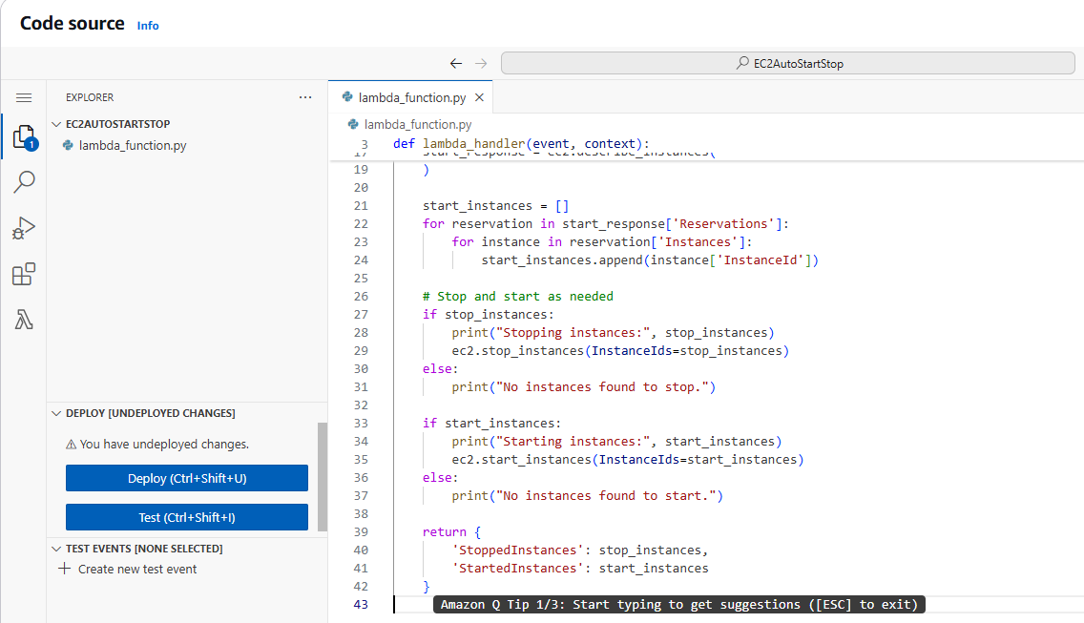

**4. Manual Invocation:**

